Resident Pre-Survey
Please complete this survey before Council Officers begin supporting the school near your residence.

- I have the read the Privacy Statement above ^{Required}
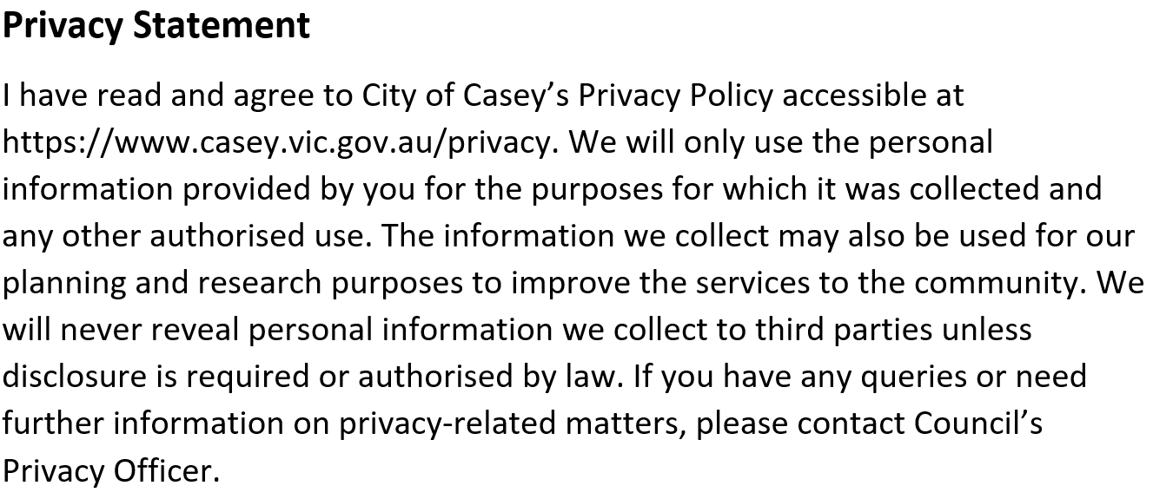

Yes

- What school do you live near? ^{Required}
- Do you have child/ren who currently attend this school? ^{Required}
Select one answer only

Yes
No
- How far away from the school do you live, approximately? ^{Required}
Select one answer only
Under 500 metres
500-999 metres
1 - 2 kilometre
more than 2 kilometres
Or supply an address if you have specific concerns you would like to advise us of

- To what extent do you agree with the following statements? ^{Required}
The people around here feel they belong to this local community
Strongly agree
Agree
Neither agree or disagree
Disagree
Strongly disagree
People in this community are willing to help their neighbours,
Strongly agree
Agree
Neither agree or disagree
Disagree
Strongly disagree
This is a close-knit community
Strongly agree
Agree
Neither agree or disagree
Disagree
Strongly disagree
People in this community can be trusted
Strongly agree
Agree
Neither agree or disagree
Disagree
Strongly disagree
People in this community generally don't get along with each other
Strongly agree
Agree
Neither agree or disagree
Disagree
Strongly disagree
People in this community don't share the same values
Strongly agree
Agree
Neither agree or disagree
Disagree
Strongly disagree
People around here believe that multiculturalism makes life in our local community better
Strongly agree
Agree
Neither agree or disagree
Disagree
Strongly disagree
People in this community enjoy living amongst people of different lifestyles
Strongly agree
Agree
Neither agree or disagree
Disagree
Strongly disagree
- To what extent do you agree with the following statements? ^{Required}
Adults in this community know who the local children are
Strongly agree
Agree
Neither agree or disagree
Disagree
Strongly disagree
There are adults in this community that children can look up to
Strongly agree
Agree
Neither agree or disagree
Disagree
Strongly disagree
Parents in this community generally know each other
Strongly agree
Agree
Neither agree or disagree
Disagree
Strongly disagree
You can count on adults in this community to watch out that children are safe and don't get into trouble
Strongly agree
Agree
Neither agree or disagree
Disagree
Strongly disagree
- Rank the following school-related traffic issues in order of importance as experienced around your residence during the previous school term. ^{Required}
Select one answer only
Not enough parking
No safe places to cross
Drivers not following the road rules
Too many cars at school at the same time
Drivers ignoring parking rules
Problems with the drop off/ pick up zone
Speeding drivers
Congestion-related frustration
Blocking driveways
Parking on nature strips
No issue
- How concerning are these driver behaviours around your school during the previous school term? ^{Required}
Parking across the road and calling for children to run across
Very concerning
A little concerning
Not very concerning
Not at all concerning
Stopping on the children's crossing to let children out of the car
Very concerning
A little concerning
Not very concerning
Not at all concerning
Stopping next to parked cars on the road and letting children out (double parking)
Very concerning
A little concerning
Not very concerning
Not at all concerning
Speeding in the school zone
Very concerning
A little concerning
Not very concerning
Not at all concerning
U-turns around the school zone
Very concerning
A little concerning
Not very concerning
Not at all concerning
- What interactions have you had with drivers about school drop off and pick up issues?
eg. Was it positive or negative? Did you experience aggression from the driver? What action/s have you taken to address the issues you are experiencing?
- Who do you believe is more responsible, if there are concerns with school pick up and drop off? ^{Required}
City of Casey Council
Highly responsible
Somewhat responsible
Neutral
A little responsible
Not at all responsible
School
Highly responsible
Somewhat responsible
Neutral
A little responsible
Not at all responsible
Whole community
Highly responsible
Somewhat responsible
Neutral
A little responsible
Not at all responsible
Police
Highly responsible
Somewhat responsible
Neutral
A little responsible
Not at all responsible

- Are there any other safety concerns and/or changes you would like to see to improve safety around school travel in your area?

About you
Before we finish, please tell us a little bit about yourself so that we can understand who we're hearing from. Click here for Council's Privacy Policy to understand how your information is used.

- I have the read the Privacy Statement above ^{Required}
Yes
- Your suburb ^{Required}
Select one answer only
Beaconsfield
Berwick
Blind Bight
Botanic Ridge
Cannons Creek
Clyde
Clyde North
Cranbourne
Cranbourne East
Cranbourne North
Cranbourne South
Cranbourne West
Devon Meadows
Doveton
Endeavour Hills
Eumemmerring
Hallam
Hampton Park
Harkaway
Junction Village
Lynbrook
Lyndhurst
Lysterfield South
Narre Warren
Narre Warren North
Narre Warren South
Pearcedale
Tooradin
Warneet
Outside of Casey
- Your age group? ^{Required}
Select one answer only
0 to 9
10 to 14
15 to 19
20 to 24
25 to 29
30 to 39
40 to 54
55 to 69
70+
Prefer not to say
- Your gender? ^{Required}
Select one answer only
Woman
Man
Transgender Female
Transgender Male
Non-binary
Prefer to not say
Self describe option here

- Please tick any of the statements that apply to you. ^{Required}
Select as many as apply
Select all that apply
I am from an Aboriginal and/or Torres Strait Islander background
I speak a language other than English at home
I am a person with a disability
I identify as LGBTIQA+
I'd prefer to not say
None of these apply to me
- What grade is your child/ren in? ^{Required}
Select all that apply
Prep
Grade 1
Grade 2
Grade 3
Grade 4
Grade 5
Grade 6
- How long have you lived at your address? ^{Required}

- Would you like to join a parent/school/community group to work on improving school travel safety?
Please provide your email so we can get in touch with you
- If you would like to go into the draw to win a $50.00 Coles/Myer Gift Card, please provide your email below

- How easy or difficult was it to find the information you needed? ^{Required}
Select one answer only
Very easy
Easy
Neutral
Difficult
Very difficult
- What was missing?
- How did you hear about the consultation on this project?
Select all that apply
Email
SMS text
Parent Portal (Central/Compass)
School newsletter
Letter
Signage
Social media
Word of mouth
Casey Conversations
Other (please specify)

