Smart City Advisory Committee Meeting
Minutes

Held in Library, meeting room 2 and 3, Bunjil Place, Narre Warren
on Monday 24 May 2020 at 6.30pm

- Welcome

“The City of Casey proudly acknowledges the traditional custodians, Casey’s Aboriginal communities and their rich culture and pays respect to their Elders past, present and future. We acknowledge Aboriginal people as Australia’s first peoples and as the traditional owners and custodians of the land on which we work and live.”

Dale Munckton, Chairperson for the Smart City Advisory Committee Meeting welcomed all.

- Present: Dale Munckton (Chair), Greg Plant, Tim McCoy, Michael Gibbs, Craig Nicholls, Marlene Hargreaves, Dheeren Velu, Shyh Wei Teng, Luke Axelby (City of Casey), Rhys Matulis (City of Casey), Marion Greig (City of Casey), Laura Baker (City of Casey), Eddi Newbond (City of Casey)

Apologies: Saurabh Jhanjee, Samantha Jansen.

Minutes: Eddi Newbond (City of Casey)

It was noted that the Councillors of the Smart City Portfolio will no longer attend future meetings due to the recent dismissal. The Council is currently under administration, the Smart City Advisory Committee will operate as usual. Council will advise the committee if there are further developments, however, it is recommended to stay informed via Council’s website under latest news section. Council’s Advisory Committees will continue to function as per normal in the immediate future as the current Advisory Committee Policy allows for Advisory Committees to function without a Councillor in attendance.

- Declaration by Councillors and Council Officers of Conflict of Interest or Personal Interest pursuant to Section 79 and 79B of the Local Government Act 1989.

- Confirmation of the minutes of previous meeting

Not Applicable due to previous meeting, November 2019, cancelled to allow commencement of the newly appointed Head of Smart City and Innovation and resume advisory committee meetings in 2020 in preparation for the Smart City Strategy redevelopment.

- Business arising from the minutes of the previous meeting

Not applicable, as above.

- General Business – overview of 2020

Casey Conversations – communications platform
Laura Baker and Luke Axelby discussed and demonstrated the new communications platform. Casey Conversations will be the key communication channel, in replacement of Slack for the Smart City Advisory Committee, it will provide a platform for the committee members and Council staff to share information, receive feedback and collate ideas and insights.

Smart City Strategy redevelopment process
Laura Baker discussed the Smart City Strategy redevelopment process, key objectives and strategy redevelopment principles. The Strategy redevelopment roadmap was discussed in detail, highlighting the key outcomes and dates, see appendix A for further details.

Smart City Strategy and Consultant partnership
The Smart City team will work in partnership with Delos Delta, after successfully being selected following an extensive quotation process. Delos Delta are a management consulting company specialising in smart cities, emerging technology, innovation and organisational transformation.

Smart City Projects and Portfolio
Eddi Newbond provided an overview of the main Smart City projects and initiatives that are in the pipeline.

Future Smart City workshop
Laura Baker conducted a Smart City workshop, addressing the committee key demands and opportunities. See appendix A, 2.1 and 3.1 summary for further details.

  - Other business
    - Smart City updates and further communication will be communication via Casey Conversations platform.

  - Expectations, next steps and actions:
    - Summary of the Smart City workshop to be distributed to committee members.
    - Further information of Delos Delta and other Councils’ Smart City Strategy to be circulated.
    - Smart City team will work with the committee members to establish a clear objective and vision statement within the advisory committee.

- Urgent items without notice

No urgent items were discussed

- Next Meeting

The next meeting is scheduled to take place on Monday, 25 May 2019 at 6:30 pm.

Meeting Closed 8.32pm

Appendix A

1.1 Strategy development roadmap

The Strategy development roadmap details the key objectives and outcomes the Smart City team are focusing on delivering and provides an overview of the engagement process between the Smart City Advisory Committee, Strategy Steering Committee (internal) and Executive Leadership team, see figure 1.1.

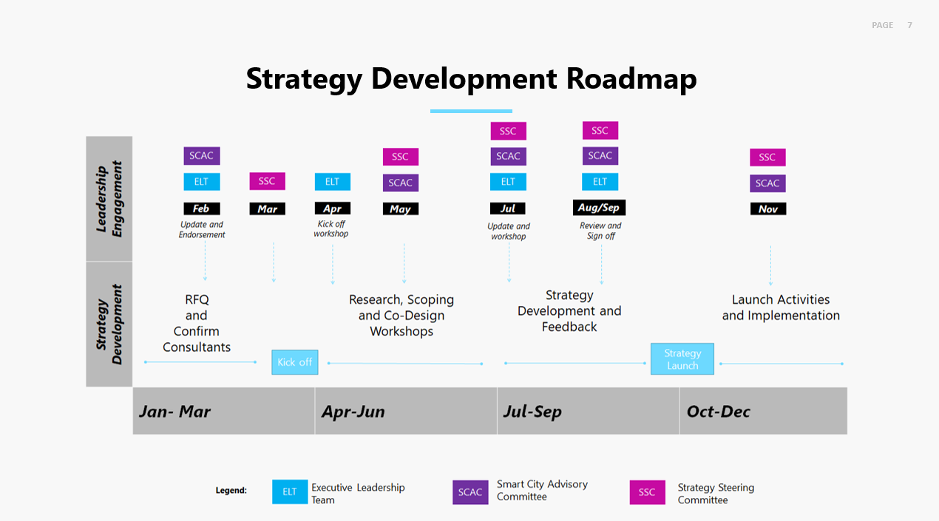
Figure 1.1 – Strategy Development Roadmap

2.1 Workshop Activity 1 Summary

Smart City success in 2020 | Committee response
Questions:  - What do you hope to achieve as a member of the Smart City Advisory Committee in 2020?  - What does success look like in 2020 for Smart City Advisory Committee?  - What is one thing you would like to see from the Smart City and Innovation team in 2020? | Break perception that things can’t happen within reasonable timeframes
 | Meaningful input, contribution, change
 | Achieve. Federation University closely, aligned Smart City Strategy
 | Tangible change. Tangible result. Not just dreams. Celebrate outcomes. Lead by example.
 | Clear expectations on committee
 | Success. Scope everything up. Clear ideas. Critique verify in collaboration with Delos Delta
 | Like to see future state of City of Casey 5 years
 | Lead by example, make things happen, collaborate
 | Projects delivered
 | Community acceptance – strategy

3.1 Workshop Activity 2 Summary
Smart City success in 2020 | Committee response
Smart City success in 2020 | Needs | Opportunities
Questions:  - What are the biggest challenges facing the community?  - What are some smart city opportunities that could be used to address these challenges? | Access to healthcare | Access to accurate information
 | Mobility  Travel | Better results from land development, community gardens, carpooling, local jobs
 | Access to local jobs | Better partnership of education with local businesses
 | Access to education | Innovation hub
 | Health and wellbeing. Lack of community | Start-up eco-system
 | Lifestyle – financial demands, travel time (working outside of Casey residence) | In home health care  Tele health
 | Emerging issues – obesity, depression, social isolation | Jobs of the future, robotics
 | Cost of living, trust, liveability, climate change | “get people with people” awareness
 | Employment, travel, health, recession | Smart traffic management
 | On-demand (transport) mobility

