Parent/Guardian Post-Survey
Please complete this survey after Council Officers have supported the school your child/ren attend.

- Does your child/ren attend Topirum Primary School? ^{Required}
Select one answer only

Yes
No
Other

- Tell us about your children ^{Required}
eg Child 1 Age/Grade/Gender
- Where in this map do you begin your journey to school?
Click 'add marker' to show where you begin your journey to school
Provide an address and your comment
- How do your children get to school most days? ^{Required}
Select one answer only
Car
Public transport
Walk
Bike/Skate/Scoot
- How do your child/ren get home from school most days? ^{Required}
Select one answer only
Car
Public transport
Walk
Bike/Scoot/Skate
- Does your child/ren sometimes walk/ride/scoot to or from school? ^{Required}
Select one answer only
At least once a week
One or twice a month
Less often
Not this year so far
- Does your child/ren sometimes get driven in a car to or from school? ^{Required}
Select one answer only
At least once a week
Once or twice a month
Less often
Not this year so far
- Has there been any change in your school travel patterns during the last school term? ^{Required}
Select one answer only
Yes
No
- If yes, please describe changes? ^{Required}

- What are the 3 main reasons your child/ren are usually driven to/from school? ^{Required}
Select 3 answers
It's quicker to drive and park than it is to travel another way
It is on the way to or from my other activities, such as travel to work
There are other children in the family to drop off / pick up
The school is too far away for them to travel another way
There are road safety dangers between home and school
They are too young to travel independently
I am worried about other personal dangers to them
Not sure, hadn't thought about it.
- What are the 3 main reasons your child/ren usually walk/ride/scoot/bus to/from school? ^{Required}
Select 3 answers
It is a short distance from school
I do not have a car available
No one is available to drive them at that time
My child is ready to travel independently
I like my children to be independent
It is healthy for my child to be active
The area is quite safe
It's quicker than driving, due to traffic
- How far does your child/ren travel to/from school? ^{Required}
Select one answer only
Less than 1km
1-1.9km
2-3km
4km or more
- If your child uses a school crossing on their journey to/from school, locate on map, by clicking 'add marker'.
Provide as many addresses as you like, with your comment for each.
- How concerning are these driver behaviours around your school? ^{Required}
Parking across the road and calling for children to run across
very concerning
a little concerning
not very concerning
not at all concerning
Stopping on the children's crossing to let children out of the car
very concerning
a little concerning
not very concerning
not at all concerning
Stopping next to parked cars on the road and letting children out (double parking)
very concerning
a little concerning
not very concerning
not at all concerning
Speeding in the school zone
very concerning
a little concerning
not very concerning
not at all concerning
U-turns around the school zone
very concerning
a little concerning
not very concerning
not at all concerning
- Rank the following traffic issues in order of importance as experienced at your school. ^{Required}
Select one answer only
Not enough parking
No drop off/ pick up zone
No safe places to cross
Drivers not following the road rules
Too many cars at school at the same time
Drivers ignoring parking rules
Problems with the drop off/ pick up zone
Speeding drivers
Congestion-related frustration
- What interactions have you had with drivers/parents about school drop off and pick up issues?
In person or online? Was it positive or negative? What was the outcome?
- To what extent do you agree with the following statements? ^{Required}
Parents in this community are comfortable with letting their children walk/ride to school
Strongly agree
Agree
Neither agree or disagree
Disagree
Strongly disagree
It is good for children's physical health to walk/ride/scoot to school
Strongly agree
Agree
Neither agree or disagree
Disagree
Strongly disagree
It is good for children's mental health to walk/ride/scoot to school
Strongly agree
Agree
Neither agree or disagree
Disagree
Strongly disagree
The people around here feel they belong to this local community
Strongly agree
Agree
Neither agree or disagree
Disagree
Strongly disagree
People in this community are willing to help their neighbours
Strongly agree
Agree
Neither agree or disagree
Disagree
Strongly disagree
This is a close-knit community
Strongly agree
Agree
Neither agree or disagree
Disagree
Strongly disagree
People in this community can be trusted
Strongly agree
Agree
Neither agree or disagree
Disagree
Strongly disagree
People in this community generally don't get along with each other
Strongly agree
Agree
Neither agree or disagree
Disagree
Strongly disagree
People in this community don't share the same values
Strongly agree
Agree
Neither agree or disagree
Disagree
Strongly disagree
People around here believe that multiculturalism makes life in our local community better
Strongly agree
Agree
Neither agree or disagree
Disagree
Strongly disagree
People in this community enjoy living amongst people of different lifestyles
Strongly agree
Agree
Neither agree or disagree
Disagree
Strongly disagree
Adults in this community know who the local children are
Strongly agree
Agree
Neither agree or disagree
Disagree
Strongly disagree
There are adults in this community that children can look up to
Strongly agree
Agree
Neither agree or disagree
Disagree
Strongly disagree
Parents in this community generally know each other
Strongly agree
Agree
Neither agree or disagree
Disagree
Strongly disagree
You can count on adults in this community to watch out that children are safe and don't get into trouble
Strongly agree
Agree
Neither agree or disagree
Disagree
Strongly disagree
- Whose job is it to fix issues with school pick up and drop off? ^{Required}
Select as many as apply.
Select all that apply

School's
Casey Council's
Police's
Community members'
Everyone's

- What does this sign mean? ^{Required}
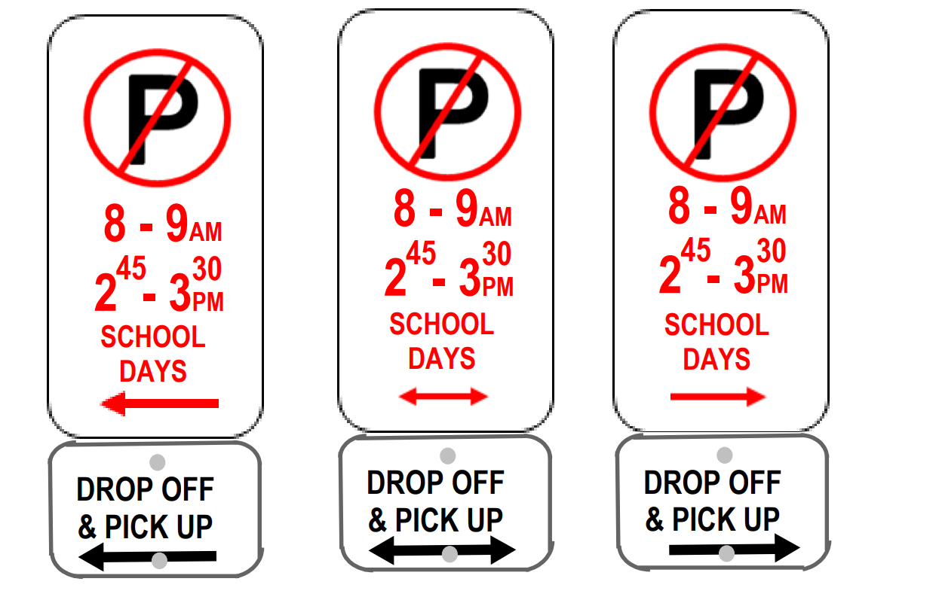
Select one answer only
The area is a pick-up/drop-off zone and I can park here for up to 15 minutes
The area is a pick-up/drop-off zone and I can stop here for up to 2 minutes
I can park here and quickly go into school to pick up my child
I can park here before school finishes and wait for my child to arrive
I cannot park here between those hours on school days
- What does this sign mean? ^{Required}
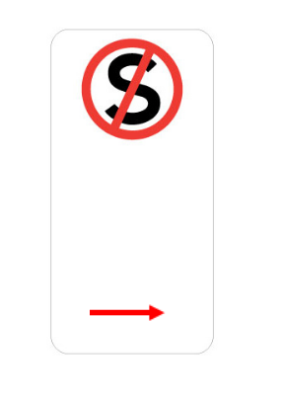
Select one answer only
I can pull over here to pick up my waiting child
I cannot park here, but I can stop for a few minutes
I cannot stop here for any purpose
I can stop here to let my child out of the car

- Did you participate in any parent/school/community groups/discussions to work on improving school travel safety during the last term? ^{Required}
Select one answer only
Yes
No
- Did you complete the survey about school travel earlier this year? ^{Required}
Select one answer only
Yes
No
- Which school communications channels did you see Safe Around Schools messaging on last term? ^{Required}
Select one answer only
Email
SMS/Text message
Parent Portal
School newsletter
Didn't see any messaging
Other

- Have you seen the Walk to School map for your school?
Select one answer only
Yes
No
Unsure
- Have you used the Walk to School map to change any aspect of your school travel? ^{Required}
Please explain
- Did you see the Speed Alert Monitoring (SAM) trailer near the school last term? ^{Required}
Select one answer only
Yes
No
Unsure
- If you would like to go into the draw to win a $50.00 Coles/Myer Gift Card, please provide your email below

About you
Before we finish, please tell us a little bit about yourself so that we can understand who we're hearing from. Click here for Council's Privacy Policy to understand how your information is used.

- I have the read the Privacy Statement above ^{Required}
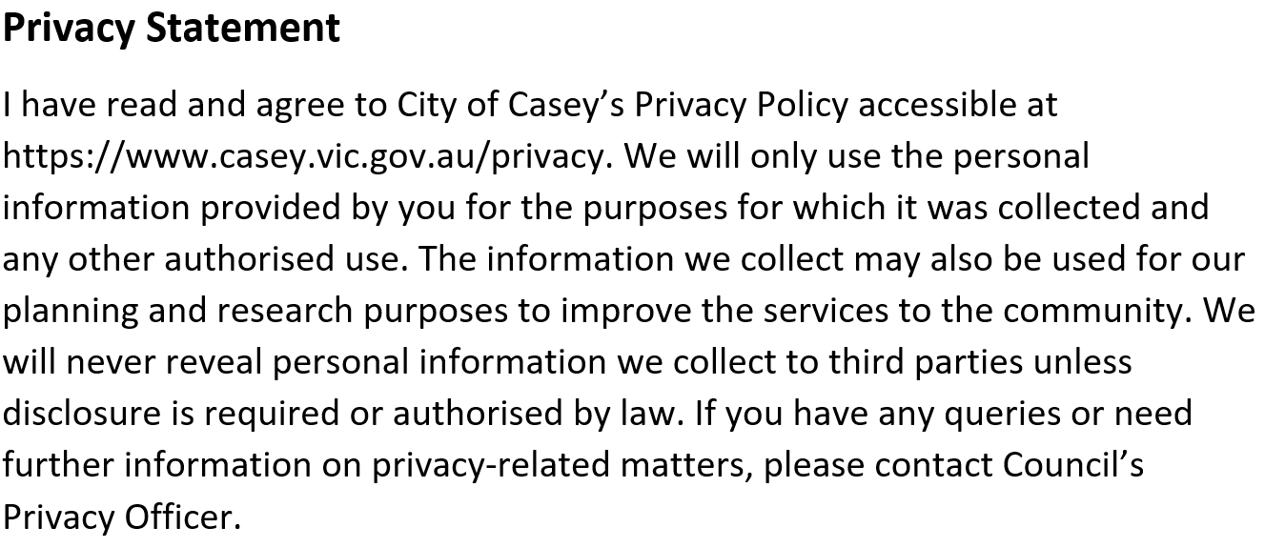
Yes
- Your suburb ^{Required}
Select one answer only
Beaconsfield
Berwick
Blind Bight
Botanic Ridge
Cannons Creek
Clyde
Clyde North
Cranbourne
Cranbourne East
Cranbourne North
Cranbourne South
Cranbourne West
Devon Meadows
Doveton
Endeavour Hills
Eumemmerring
Hallam
Hampton Park
Harkaway
Junction Village
Lynbrook
Lyndhurst
Lysterfield South
Narre Warren
Narre Warren North
Narre Warren South
Pearcedale
Tooradin
Warneet
Outside of Casey
- Your age group?
Select one answer only
0 to 9
10 to 14
15 to 19
20 to 24
25 to 29
25 to 39
40 to 54
55 to 69
70+
Prefer not to say
- Your gender?
Select one answer only
Woman
Man
Transgender Female
Transgender Male
Non-binary
Prefer to not say
Self describe option here

- Please tick any of the statements that apply to you. ^{Required}
Select as many as apply
Select all that apply
I am from an Aboriginal and/or Torres Strait Islander background
I speak a language other than English at home
I am a person with a disability
I identify as LGBTIQA+
I'd prefer to not say
None of these apply to me
- How long have you lived at your address? ^{Required}
- How many vehicles do you have at this address? ^{Required}
- What is your annual combined household income (before tax) from all sources? ^{Required}
Neighbourhood cohesion and school travel decisions can be influenced by many elements including socioeconomic factors. Asking this question about household income gives important context for how these contributors are interacting in the Casey context.
Select one answer only
$0-$30,000 a year
$31,000-$60,000 a year
$61,000-$90,000 a year
$91,000-$120,000 a year
$120,000+ a year
Prefer not to answer

- How easy or difficult was it to find the information you needed? ^{Required}
Select one answer only
Very easy
Easy
Neutral
Difficult
Very difficult
- What was missing?
- How did you hear about the consultation on this project?
Select all that apply
Email
SMS text
Parent Portal (Central/Compass)
School newsletter
Letter
Signage
Social media
Word of mouth
Casey Conversations
Other (please specify)

