


CASEY.VIC.GOV.AU

Road Management Plan

Version: Draft

Date updated:

Responsible Department: City and Asset Planning

- Purpose

The purpose of this document is to meet the requirements of a Road Management Plan as defined by the Road Management Act 2004. This plan documents the standards, policies and management systems used by the City of Casey to discharge its duty to manage, inspect, repair and maintain the roads for which it is responsible.

Definitions

Council | Means Casey City Council, being a body corporate constituted as a municipal Council under the Local Government Act 1989
Councilors | Means the individuals holding the office of a member of Casey City Council
Council officer | Means the Chief Executive Officer and staff of Council appointed by the Chief Executive Officer.
The Act | For the purposes of this Policy, The Act refers to the Road Management Act 2004.

- Scope

The objective of this document is to clearly define:

  - The road assets the Council maintains
  - The standards, policies and procedures used to maintain those assets
  - The processes used to establish the appropriate standards.

The scope of this plan is restricted to the specific requirements identified in the Code of Practice for Road Management Plans.

This plan covers only the roads and road sections on Council’s Register of Public Roads that are identified as being the responsibility of the City of Casey.

Context

Road Management Act 2004

The purpose of the Road Management Act 2004 (The Act) is to enable the coordinated management of public roads that will promote safe and efficient State and local public road networks, and the responsible use of road reserves for other legitimate purposes.

The City of Casey is the ‘coordinating road authority’ as defined by The Act for all roads within its boundaries, with the exception of the road network maintained by the Department of Transport (DoT). The Act requires Council to identify on its Register of Public Roads all roads for which it is the coordinating road authority that Council considers are reasonably required for general public use. The City of Casey is the responsible road authority for all roads on the register, and road infrastructure on DoT’s roads for which the Council is identified as having care and management responsibility.

The Act sets out the powers and duties of the road authority to install, manage and maintain infrastructure for which it is the responsible authority. The Act also provides a policy defence for road authorities where they can demonstrate responsible management through an adopted Road Management Plan.

Council responsibility

The Council has the power to determine the standard to which it will construct, inspect, maintain and repair roadways as set out in The Act. The Council is responsible for implementing processes and systems to ensure compliance with those standards.

Road-user responsibilities

Road user obligations are set out in Section 17A of the Road Safety Act 1986 (as amended by the Road Management Act 2004) and summarised below.

A person who drives a motor vehicle on a highway must drive in a safe manner having regard to all relevant factors including (but not limited to) the:
  - physical characteristics of the road
  - prevailing weather conditions
  - level of visibility
  - condition of the motor vehicle
  - prevailing traffic conditions
  - relevant road laws and advisory signs
  - physical and mental condition of the driver.

A road user other than a person driving a motor vehicle must use a highway in a safe manner having regard to all the relevant factors.

A road user must have regard to the rights of other road users and the community, taking reasonable care to avoid conduct that may:
  - endanger the safety and welfare of other road users
  - damage any infrastructure on the road reserve
  - harm the environment of the road reserve.

Policy

The Code of Practice for Road Management Plans outlines the contents for a Road Management plan. Those contents are included in this document as follows:

Heading | Location in this Document | Contents of a RMP as defined by  Code of Practice
City of Casey’s road infrastructure | Appendix A | A description of the types of road infrastructure for each of the classes of public roads for which the road authority is the responsible road authority.
Management System | Appendix B | Details of the management system, which is established or is to be established and implemented by the road authority to discharge its duty to inspect, maintain and repair
Inspections | Appendix C | A description of the inspections required for different types of road infrastructure;
Service Standards | Appendix D | The standard or target condition to be achieved in the maintenance and repair of  different types of road infrastructure

In setting these inspections, standards and systems the authority is required to take account of community expectations, utilisation of assets, risk, environmental and cultural factors, and available resources. These factors are accounted for through Council’s Asset Management Plans that take a long-term holistic view to managing Council’s assets, and are considered in detail in the four-yearly review of this Road Management Plan.

Administrative updates

It is recognised that, from time to time, circumstances may change leading to the need for minor administrative changes to this document. Where an update does not materially alter this document, such a change may be made administratively. Examples include a change to the name of a Council department, a change to the name of a Federal or State Government department, and a minor update to legislation which does not have a material impact. However, any change or update which materially alters this document must be by resolution of Council.

Review

This Road Management Plan is required by the Road Management (General) Regulations 2016 to be reviewed within the same period that Council prepares its Council Plan. A summary of the findings of this review is available with this Plan at http://www.casey.vic.gov.au/roads-drains/roads/road-management-plan.

.

Appendix A: City of Casey’s road infrastructure

Description

The City of Casey is the coordinating road authority and the responsible road authority for more than 1,800 kilometres of roads within its boundaries. DoT is the coordinating road authority for the main road network and is responsible for more than 177 kilometres of roads.

Approximately 82 per cent of Casey’s roads are in urban areas and usually include footpaths and road furniture, and kerb and channel that discharge into a drainage network. The remaining roads are classified as rural with stormwater usually controlled by open drains and culverts.

Road hierarchy

Roads within the City of Casey are given a road hierarchy classification based on factors including traffic volume, traffic type and accessibility, as shown in the table below. These classifications are recognised and adopted throughout Casey for classifying roads.

Road Hierarchy | Responsibility | Primary Function
Freeway | DoT | A road which has fully controlled access and provides the principal route for movement of goods and people from one region to another.
Primary  arterial | Council/DoT (Shared responsibilities between DoT and Council as detailed in the RMA & Code of Practice) | Roads whose main function is to form the principal routes for the movement of goods and people, predominantly from one region to another. Access to abutting properties and lower order roads is typically controlled or denied.
Secondary  arterial (Major roads) | Council | Roads that supplement the primary arterial roads, providing through traffic movement to an individually determined limit, sensitive to roadway characteristics and abutting land uses. These roads provide a direct traffic link from one part of a region to another. Access to abutting properties and lower order roads is typically limited.
Trunk  collector | Council | Roads that provide a specialised form of connection between the local streets and the arterial network where – due to localised constraints – traffic is required to be concentrated at a level higher than desirable for a collector road. Access to abutting properties is permitted; however, the traffic function of the road is clearly recognised.
Collector | Council | Collector roads are important local roads whose function is to distribute traffic between the arterial roads and the local road system and to provide access to the abutting property. A reasonable level of local amenity is maintained by restricting traffic volumes and vehicle speeds. The collector street may be used as a bus route.
Local  access | Council | Roads or streets not having a significant through traffic function. These roads provide access to abutting property. The local environment is dominant, traffic is subservient, speed and volume are low and pedestrian and cycling movements are facilitated.
Limited  access | Council | Access is primarily for abutting properties and/or non-vehicular through traffic. Examples include: laneways; equestrian, bicycle or pedestrian trails; and some multiple-property access ways.
Car parks | Council | All off-street car parks maintained by the Council and listed on its register of public roads.

Path Hierarchy

Paths within the City of Casey are classified as Priority and Non-Priority. Paths around shopping/business districts, schools and other high visitation community facilities where displacements between path slabs could present a higher risk may be designated as Priority and the remainder as Non-Priority. Designated shared paths are maintained to the same standards as footpaths.

Bridge Hierarchy

Bridges within the City of Casey are broadly classified as road and pedestrian bridges. Pedestrian bridges are further classified into high and low priority inspection regimes. Pedestrian bridges of timber structure and those with their age greater than 30 years are in the high priority inspection regime and the remainder are in the low.

Register of Public Roads

The City of Casey Council’s Register of Public Roads (Register) defines the public roads and their classifications for all roads for which Council is the coordinating road authority. The Register is maintained by Council as a controlled document and is available for public inspection at Council offices in Narre Warren or on Council’s website. Descriptions on the Register are supported by map information on Council’s geographic information system. Maps for specific roads showing the extent of the area maintained, can be provided on request from Council’s Narre Warren offices.

Council’s policy for registering or removing a road on or from the Register is available from Council’s website or Narre Warren offices.

For each road, the main details the register records are:

  - Name of each public road
  - Date on the which the road became a public road
  - Identification of start and end points
  - Locality
  - Classification
  - Details of changes to the status of the road as required by the Road Management Act.

Assets covered by this plan

The assets covered by this plan are confined to those for which Council has statutory responsibility under the Road Management Act 2004.

These assets are defined in the Road Management Act as:

  - Roadway
  - Pathway
  - Shoulder
  - Road-related infrastructure.

In keeping with these definitions, the following assets on roads identified in Council’s Register are covered by this plan:

  - Road surface and supporting pavement
  - Constructed pathways (pedestrian, shared and equestrian)
  - Car parks within road reserves
  - Road shoulders
  - Traffic control devices (traffic signals, line marking, speed control devices)
  - Bridges and large culverts as part of roads infrastructure
  - Kerb and channel
  - Signs (regulatory and advisory).

Although Council also carries out inspection and maintenance of roadsides, fire hydrants, street trees and information signs, the maintenance and inspection of these assets is outside the scope of this plan. The operation and maintenance of these assets are covered by separate operational plans.

Council is not responsible for the management and maintenance of utility assets (e.g. water and sewerage networks, telecommunications, electricity and gas) within the road reserve. These assets are the responsibility of their respective utility provider.

Streetlights in road reserves provide a service to the community and are funded by the Council but are owned and maintained by the respective network provider. They are therefore not covered by this plan. The levels of service relating to these assets are considered through the Asset Management Plan and arrangements made directly with the appropriate utility.

Roadside vegetation

A road authority does not have a statutory duty or a common law duty to maintain, inspect or repair land of any public highway that is not a constructed path or roadway (RM Act s.107). Nature-strips in urban areas are the responsibility of the neighbouring landowner to maintain.

Access to private property

Access to private property is provided by a ‘vehicle crossover’, which is defined as infrastructure to allow the passage of vehicles between the road formation (or kerb and channel, where it exists) and the property boundary. Vehicle crossovers may serve several properties.

Section 107 of the Roads Management Act 2004 provides that Council is under no statutory duty to inspect, maintain or repair vehicle crossovers on road reserves that provide access to land adjoining a road. This responsibility rests with the adjoining landowner. The construction of a vehicle crossover requires a permit and must be carried out to Council standards. Where modifications to Council assets (e.g. paths and kerb and channel) are required, these shall be at the landowner’s expense. The landowner is responsible for ensuring the vehicle crossover and the immediate surrounds that the crossover impacts on, are maintained in a safe condition. Council’s responsibility is limited to requiring the landowner to rectify any hazards of which it becomes aware.

In urban areas, Council has ownership for any footpaths and kerbs and channels. The landowner has ownership and responsibility for the remainder of the vehicle crossover on Council property. In rural areas where there is no footpath or kerb and channel, the landowner is responsible for the entire vehicle crossover, including any culverts that may be required.

Roadside maintenance responsibilities in urban areas are shown diagrammatically in Figure 1
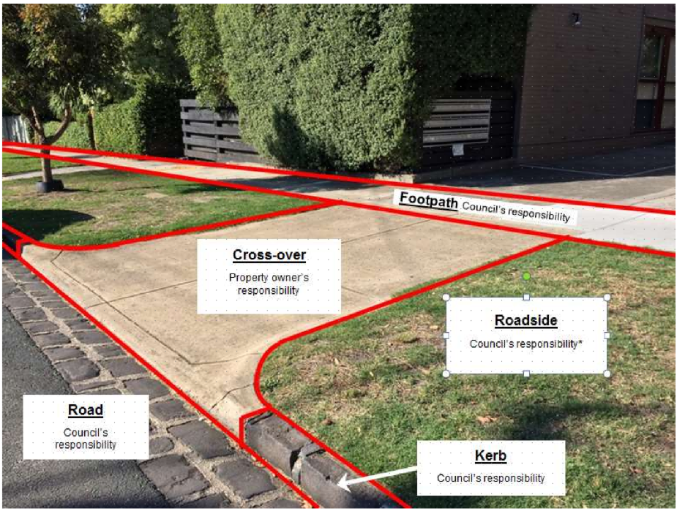
Nature Strip

Property owner’s responsibility
Figure 1: Maintenance Responsibilities for Urban Roadside

Consent to perform works on road reserves

Any person who wants to undertake works in a road reserve must obtain consent from the relevant road authority unless they are exempted under Roads Management Regulations 2005. For works on Council roads, a permit has to be obtained from Council. Residents can get advice by contacting Council customer service during the normal working hours by phone (03 9705 5200) or in person at any of the customer service centres.

Demarcation and transfer or responsibility

The City of Casey is bounded by six municipalities: the City of Greater Dandenong, Frankston City Council, Shire of Mornington Peninsula, Shire of Cardinia, Shire of Yarra Ranges and the City of Knox.

The municipal boundary is often the centreline of a road, or follows a watercourse over which bridges or culverts have been constructed. Council has agreements with the neighbouring municipalities for boundary roads to clearly assign maintenance responsibilities for the whole road or bridge to one or other of the authorities. The agreement also identifies capital works responsibilities.

Melbourne Water manages the main drainage network and owns a number of bridges and culverts that support Council roads. The City of Casey ensures that, with respect to the ability of the bridge to provide a safe crossing for traffic, these structures are inspected and maintained as for Council owned bridges.

DoT has an agreement with the City of Casey which defines the maintenance responsibilities on main roads owned by DoT. In general, in urban defined areas DoT maintains the road pavement and kerb and channel, while the City of Casey maintains the road reserve and footpath.
The following diagram illustrates a typical example of the relationship between assets managed by the City of Casey and assets managed by DoT. In this example, the City of Casey is responsible for the management of footpaths, outer separators (nature strips), trees, service roads, and the roadside furniture within the road reserve. DoT is responsible for the main carriageway (including kerb and channel), centre median strip, lighting, and any additional road-related infrastructure defined in the Road Management Act 2004.

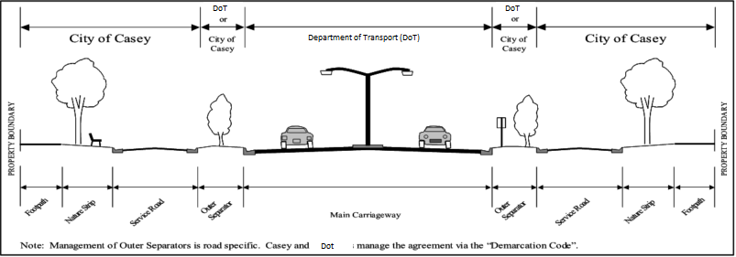

Figure 2: Cross section showing responsibilities on typical primary arterial Road

The following table details the relationships and agreements between the City of Casey and adjacent authorities.

Name | Authority | Relationship | Documented Agreement
City of  Greater Dandenong | Local  Government | - Maintenance of boundary streets by City of Casey and City of Greater Dandenong.  - Maintenance of footbridge by City of Casey. | In place
Frankston  City | Local  Government | - Maintenance of boundary streets by City of Casey and Frankston City. | In place
Mornington  Peninsula Shire | Local  Government | - Maintenance of boundary streets by City of Casey and Shire of Mornington Peninsula. | In place
Shire of  Cardinia | Local  Government | - Maintenance of boundary streets by City of Casey and Shire of Cardinia.  - Maintenance of one traffic bridge by City of Casey.  - Maintenance of one traffic bridge by City of Cardinia. | In place
Shire of  Yarra Ranges | Local  Government | - Maintenance of boundary roads by Shire of Yarra Ranges. (City of Casey pays an annual maintenance fee.) | In place

Name | Authority | Relationship | Documented Agreement
City of  Knox | Local  Government | - Maintenance of boundary streets by City of Casey and City of Knox. | In place
DoT | Main Roads  Authority | - DoT owns main roads.  - Maintenance of pavement and kerb and channel by Dot.  - Maintenance of road reserves and footpaths by City of Casey. | In place
South East  Water | Water  Authority | - South East Water owns and maintains all water mains and sewerage system within City of Casey. | Management of  road utilities infrastructure in road reserves
VicTrack | Rail Authority | - VicTrack maintains the assets on rail track reserve
Ausnet | Electricity Utilities | - Ausnet owns and maintains the electricity assets
AGL | Gas  service | - AGL owns and maintains the gas network.
TXU | Gas and  Electricity | - TXU owns and maintains gas and electricity assets.
ABN Co | ABN | - Maintains the ABN network
Telstra | Tele-communications (incl. cable TV) | - Telstra owns and maintains the telecommunications network in the City of Casey.
Optus | Cable TV | - Optus owns and maintains a portion of the telecommunications network in the City of Casey.
Aquasure | Desalination Pipeline | - Aquasure maintains the desalination pipes

Utility owners have rights of access to road openings and installation and maintenance of their assets in accordance with the Code of Practice for the Management of Road and Utility Infrastructure in Road Reserves.

Appendix B: Management System

Managing asset information

The Council’s asset information is stored on an electronic database known as the Asset Management System (AMS). This system is continually being developed and enhanced. The AMS is also increasingly being used to manage information on risk and to model deterioration and replacement scenarios.

Identifying hazards

Hazards or defects in road infrastructure are identified through inspections and recorded in the Council’s database. Inspections can be initiated either as part of a scheduled program as set out in Appendix D or by a request for service. Requests for service (either generated internally or in response to a customer request) are responded to using the process identified in Figure 3. All inspections are conducted by vehicle with the exception of paths which are conducted on foot.

Frequencies for routine inspections are developed for each asset group based on risk and rates of deterioration. For example, if not dealt with promptly, conditions on unsealed roads and unsealed shoulders of sealed roads can rapidly change resulting in increased maintenance cost and safety hazards, justifying frequent inspections. Footpaths adjacent to business districts, schools and facilities are identified for 6 monthly inspections and higher maintenance activity than other footpaths that have less use.

The inspection frequency for road pavements (other than unsealed roads) is carried out according to the road hierarchy. Secondary arterial and Trunk collector roads are considered to pose a greater risk because of their higher traffic loads, and therefore have more frequent inspections.

Assessing condition

The purpose of condition inspections is to assess the remaining life of an asset; for financial purposes (calculation of depreciation); and for planning and prioritisation of the City of Casey’s capital works program. The condition assessment processes also have provision for recording hazards and maintenance defects which are reported separately for action through the maintenance management system.

Roads and bridges are inspected and rated for condition at least every five years. However, roads that have shown signs of deterioration are inspected more frequently so that intervention takes place at the most appropriate time. Footpaths are inspected and assessed every three years to determine their condition and develop work programs.

All condition inspections are conducted by a vehicle with the exception of paths condition inspection which is incorporated with the path hazard inspection and is conducted on foot.

Prioritising work

Requests for service and works orders are initially screened and ‘high’ risk situations are dealt with immediately to manage the risk. If immediate repairs are not practicable, steps are taken to reduce the risk and the appropriate intervention is then scheduled. Activities are programmed to meet the response times identified in Appendix D.

Delivering and auditing maintenance programs

Maintenance activities identified in Appendix D are carried out by a combination of in-house resources and external staff.

The City of Casey has the following processes in place to ensure that planned processes and activities are actioned:
  - The Contract Supervisor/Team Leader is responsible for monitoring works activities and reporting results on a quarterly basis.
  - Customer Service statistics (response times etc.) are measured and reported quarterly.
  - Appropriate Team Leader/Head carries out monthly spot checks to verify operation of data collection process.
  - Processes from initial request or inspection result, through to work done and recording are audited externally every second year by Council’s insurer.

The monitoring of work activities is carried out through the Asset Management System through on-line queries, and standard and custom reports. Non-compliance with standards will be reported to the Manager City Presentation.

Reactive requests are actioned in accordance with the process shown in Figure 3.

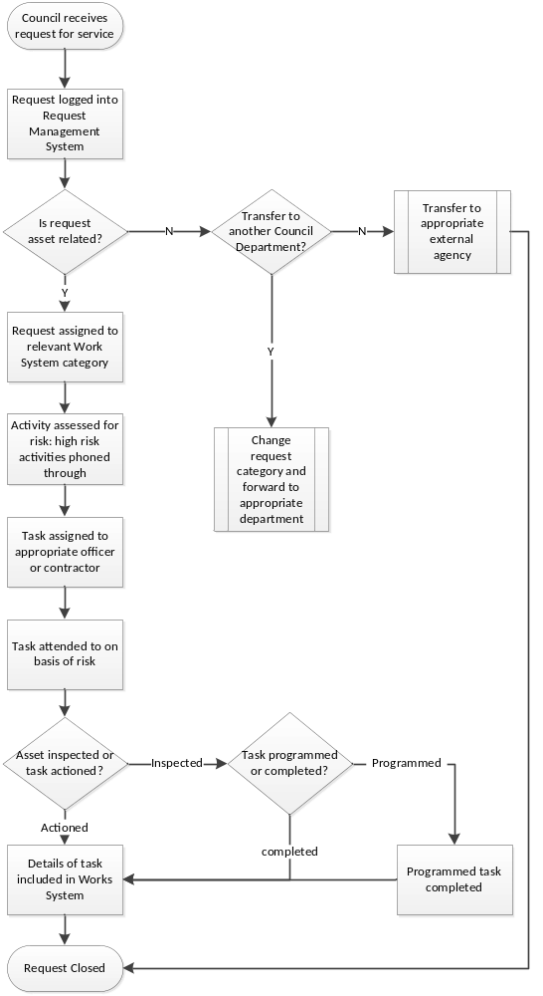
Figure 3: Process to Manage Request for Service

Replacement programs

Pavement resurfacing, rehabilitation and footpath renewals are the main replacement activities undertaken on City of Casey road assets.

The type and nature of replacement activity undertaken for road pavements depends on:
  - Condition of the asset
  - Road classification
  - Traffic volumes
  - Proportion of commercial vehicles
  - Subgrade conditions
  - Rural and urban environment
  - Economic factors.

In conjunction with inspection data and priority lists, the City of Casey utilises a pavement management system to model the timing and type of renewal and replacement activities that are undertaken to remove defects and manage the overall condition of roads within the municipality.

Spray seal surfaces (comprising a sprayed bitumen layer with stone aggregate topping) are common in rural areas and are replaced on a seven-year cycle approximately.

Asphalt (comprising a mix of graded aggregate and bituminous binder) is predominantly used for urban roads and is replaced when it deteriorates to a minimum condition level, usually after 25 to 30 years. This surface type is predominant in urban areas.

Tactics for new and upgraded assets

The City of Casey’s road network is still developing, and continued investment is required to upgrade existing assets and provide new assets.

New residential streets are generally created as a condition of subdivision developments and the roads vested in the Council.

The Council has a prioritised unsealed road program to construct and seal selected unsealed roads. Residents may apply to have other roads constructed and sealed on the basis that such upgrades would be subject to full cost recovery from owners of land fronting the road through a special charge scheme established for that purpose.

The City of Casey has a number of strategies that provide guidance in regard to the need and location of new roads. Principally these strategies relate to the future development of green-field sites and the associated infrastructure required to service these areas.

The strategies adopted include:
    - .
    - Integrated Transport Strategy – which provides a policy framework to guide the detailed planning of transport infrastructure in the municipality.

Disposal tactics

As part of the delivery of cost-effective services, Council may consider the disposal of assets and, in doing so, will take into account risk, costs and benefits, and adverse effects. Council will dispose of assets only after appropriate notification and full consultation with affected parties.

Events beyond the control of Council

Council will make every endeavour to meet all aspects of its Road Management Plan. However, in the case of natural disasters and events (including fires and floods) as well as human factors (including lack of Council staff or suitably qualified contractors) Council reserves the right to suspend compliance with its Plan in accordance with Section 83 of the Victorian Wrongs Act 1958 (as amended).

Pursuant to Section 83 of the said Act, in the event of limited financial resources of Council and conflicting priorities where the Chief Executive Officer concludes the Road Management Plan cannot be fully implemented, the Chief Executive Officer will write to Council’s officer in charge of implementing the plan (Manager City Presentation) and inform them that some, or all of the timeframes and responses in Council’s Plan are to be suspended.

Once the events beyond the control of Council have abated, or if the events have partly abated, Council’s Chief Executive Officer will write to Council’s officer responsible for implementing the plan and inform them what parts of Council’s Plan are to be reactivated and when.

Appendix C – Inspections

Reactive inspections

The table below describes reactive inspections carried out on road assets within the City of Casey in response to a request for service, whether generated externally through a customer request or internally form incidental observations by Council Staff.

Type | Inspection details | Person | Reporting details
Emergency/safety | Defects identified as likely to create a danger or serious inconvenience.  Risk reduced by repair, barricades or warnings as appropriate, within 6 hours from the time it’s initiated through the 24 hours, 7 days a week Council call out service. | Council representative with knowledge of road maintenance techniques.  Additional expertise brought in as required. | Identify specific defect, time first reported, time inspected, by whom, subsequent action and time of completion. Recorded in database.
Reactive maintenance | Non-urgent (potential risk but no immediate danger; e.g. street name plate missing) inspections carried out within 10 working days. Any work requirements are recorded and prioritised in conjunction with results of programmed inspections. | Technical officer or asset inspector with knowledge and experience of road maintenance techniques. | As above.

Routine inspection Description

The following table describes how routine inspections are carried out.

Type | Inspection details | Person | Reporting details
Condition | Routine inspections to identify capital works requirements to feed into AM prioritisation processes | Carried out under direction of qualified engineer or experienced technical officer with extensive knowledge and experience in road construction and maintenance practices | Details recorded electronically against asset or component level (as appropriate) and loaded into asset management system
Risk/ maintenance | Routine inspections specifically to determine priorities for maintenance works program | Technical officer or asset inspector with knowledge and experience of road maintenance techniques. | Record of each street /road detailing person completing, date time and description of defects.

Routine Inspections – Condition

The table below sets out the routine condition inspection regime used to estimate remaining life for establishing capital works programs and calculating depreciation.

Asset | Classification | Inspection description | Frequency
Pavement | Flexible and rigid sealed pavement | Surface inspection for defects, cracking, roughness, rutting | 5 years maximum (depending on condition of last inspection)
Pavement | Flexible and rigid sealed pavement | Structural pavement testing | Selected roads where construction planned
Paths | Concrete | Visual condition survey | Incorporated into routine inspections
Kerb and channel | All | Visual condition survey | 5 years - in conjunction with pavement condition inspection
Bridges | All | Condition survey (Level 2) | 5 years maximum (depending on condition of last inspection)
Bridges | All | Structural safety and load capacity (Level 3 and 4) | As determined from Level 1 and 2 inspections

Other assets and classifications are currently not condition rated.

Routine Inspections – Risk / Maintenance

The following tables identify the inspections and frequencies for each asset class.

Classification | Inspection description | Frequency | Maximum interval between inspections
Pavement and kerb
Secondary Arterial | Maintenance and  hazard inspection of road surface and kerbs | 3 Months | 16 weeks
Trunk Collector | Maintenance and  hazard inspection of road surface and kerbs | 6 months | 30 weeks
Other sealed roads (Collector, Local Access, Limited Access and all carparks) | Maintenance and  hazard inspection of road surface and kerbs | Yearly | 60 weeks
Unsealed Roads, (all classifications) | Maintenance and  hazard inspection of road surface | Monthly | 6 weeks
Unsealed  shoulders of sealed roads | Maintenance and  hazard inspection | Monthly | 6 weeks
Footpath and shared paths
Priority areas – Concrete/asphalt/ Pavers | Defect and hazard  inspection of footpath | 6 months | 60 weeks
Non priority areas –  Concrete | Defect and hazard inspection of footpath | 3 years | 4 years
Non priority areas –  Unsealed / gravel | Maintenance and hazard inspection of footpath | Yearly | 60 weeks
Non priority areas –  Asphalt | Maintenance and hazard inspection of footpath | Yearly | 60 weeks

Classificatio  /..,nbn | Inspection description |  | Frequency |  | Maximum interval between inspections
Street furniture/signage (regulatory and advisory)
All Roads | Maintenance and  hazard inspection |  | Yearly |  | 60 weeks
Night-time inspection on Secondary Arterial Roads | Night-time inspection  of reflectivity on secondary arterial and intersecting roads |  | Yearly |  | 60 weeks
Sealed Roads line marking

All Roads | Maintenance Inspection of line marking on all relevant roads (including controlled intersections) and car parks |  | Yearly |  | 15 months
Pedestrian and school crossings | Maintenance inspection and school and pedestrian crossings (all roads) painting. |  | Yearly |  | 15 months
Drainage
Side entry pits on  roads | Maintenance  inspection and cleanout | 2 yearly |  | 2 years, 3 months
Bridges
Road bridges | Level 1 hazard and  maintenance inspection | 24 weeks |  | 28 weeks
Pedestrian Bridges
High priority | Level 1 hazard and  maintenance inspection | 12 weeks |  | 16 weeks
Low Priority | Level 1 hazard and  maintenance inspection | 24 weeks |  | 28 weeks
Horse trails
Constructed (gravel)  horse-trails | Maintenance and  hazard inspection | Yearly |  | 60 weeks

Appendix D – Service Standards

The development of standards

Through the Council’s Asset Management Plan, key stakeholders are defined and their expectations identified in terms of accessibility, safety, responsiveness, quality, cost effectiveness and environmental considerations. Customer expectations have initially been inferred by Council staff involved in service delivery for road activities and are modified as information from ongoing research (customer requests and feedback analysis, focus groups and surveys) becomes available. Where appropriate, these expectations are translated into standards which are modified through the Council’s asset management planning process to:

  - Achieve Council’s goals and objectives
  - Meet minimum legislative requirements
  - Reduce overall costs through timely response.
Inspection standards (nature and frequency) are determined to meet the above requirements and are confirmed through a risk assessment in accordance with Council’s risk management framework. These standards are tabled in Appendix D.

The technical standards are assessed prior to each review of this plan and the standards modified to minimise risk and take account of any legislative changes.

Road safety

The number of reported accidents on Council roads has averaged around 183 accidents annually over the past five years. The average number of fatalities has remained the same at 2.6 over the past five years despite a significant increase in traffic volume on Council roads. Road safety is an important focus for Council’s traffic management section.

Specific sites identified with a recurring accident trend are assessed for suitability for remedial treatment under a range of Federal, State and Local Government safety programs.

Construction standards

The standards for new road infrastructure are set out in the Engineering Design and Construction Manual provided by the Victorian Planning Authority. While new infrastructure is designed and constructed in accordance with these standards, there is no obligation on Council to upgrade any existing infrastructure which may not be built according to this standard.

Reactive maintenance and intervention levels

Intervention levels define the circumstances under which a defect is no longer tolerable for a stated level of service. The timeframe in which to address these defects once they are found is determined from an analysis of risk, benefits and costs. Examples of these levels and the associated maintenance activities are described in the tables below.

Key Task | Intervention levels | Response  times | Performance standard
Roads and street furniture
Response to  emergency call outs | - Spill creating slippery or other hazardous situation  - Roadwork site unsafe (e.g. signage, plant or materials)  - Obstacles on roadway or shoulder  - Potholes, severe pavement subsidence or surface damage  - Flooding in road reserve  - Missing drainage pit lid  - Unserviceable guard rail  - Structural bridge damage reducing capacity or significant bridge surface defect | 6 hours  (immediately after initiation, for 7 days a week) | Site inspected and risk reduced appropriately as required
Response to  emergency call outs |  | 48 hours  (immediately after initiation, for 7 days a week) | Assess situation and determine remedial treatment
Sealed roads  pot-hole patching | Repair all potholes greater than 300mm diameter and 50mm depth | 10 working  days | Hole is to be repaired to provide a smooth, safe surface consistent to line and level of surrounding pavement

Key Task | Intervention levels | Response  times | Performance standard
Roads and street furniture (continued)
Sealed roads  - repair of shoulders | Maintenance is required when:  - the drop from the traffic lane to the shoulder exceeds 75mm over any length, or  - when there are more than 20 potholes per km of single shoulder of depth greater than 50mm or  - where corrugations exceed 30% of the area of a single road shoulder per km | 10 working  days | Provision of a safe trafficable surface which is free draining and prolongs the pavement life
Kerb and channel displacement | Tripping hazard identified with  displacement between kerb sections exceeding 80 mm | 20 working days | Restore the alignment and level of the kerb or channel with either replacement of a sections or smoothing the displacement using an asphalt fillet, concrete slurry or similar suitable material. If these repairs are not practicable, the defect will be highlighted with paint until it can be rectified.

Key Task | Intervention levels | Response  Times | Performance  standard
Roads and street furniture (continued)
Unsealed roads maintenance | When pavement defects (as  specified) and/or loose material (greater than 40mm deep) exceed 20% pavement surface area per km | 20 working days | Unsealed roads maintenance
Pedestrian and  school crossing maintenance | Timber posts to be replaced  when damaged or greater than 50% wood rot is evident | 5 working  days | All crossings and related furniture to be in good conditions and highly visible at all times
Road regulatory  and advisory signage maintenance | Road signs missing or  illegible | 20  working days | Clean or replace damaged signs
Guard rail  maintenance | Guard rails in damaged  condition (other than immediate safety hazards) | 20 working days | Guard rails restored to provide safety to road users and protection of pedestrians and assets.
Guide post  maintenance | Damaged posts/delineators.  50% of the white face of the post is noticeably degraded or faded. | 20 working days | Posts/delineators replaced to provide clear delineation of the road shoulder edge and culvert/bridge locations
Sealed Roads line marking | When line marking is faded, eroded, worn or non-reflective. | Program | Works programmed for repainting in the next financial year

Key Task | Intervention levels | Response  times | Performance  standard
Footpath and Shared Paths
Response to  emergency call outs | Surface collapse or obstacle.  Other situations on paths assessed by Council Officers as being of immediate priority | 6 hours | Site inspected and  risk reduced appropriately as required.
Footpath/shared  path - concrete | Hazard identified with  displacement > 20 mm or crack width more the 20mm over length of 0.5 m | Priority  areas - 10  working days | Grinding, filling with  asphalt or replacing the slabs. If these repairs are not practicable, the defect will be highlighted with paint until it can be rectified.
Footpath/shared  path - concrete |  | Non-priority areas – 30  working  days
Footpath/shared  path - asphalt | Whenever the number of  potholes exceed two (2) per 100m of footpath or potholes are greater than 100mm diameter or 25mm in depth  Whenever cracking exceeds 2m in length and 10mm in width  Wherever pavement shows significant concentrated levels of distress | 30  working days | Footpaths to be free of potholes and surface defects including depressions that hold water and cracking in sealed pavements greater than 10mm in width and 2m in length.
Footpath/shared  path - unsealed | Whenever pavement shows  significant concentrated levels of distress  Whenever scours of depth greater than 50mm occur at any location | 30  working days | Footpaths to be free of potholes and surface defects including depressions that hold water

Key Task | Intervention levels |  | Response  times | Performance standard
Horse trails | Whenever trail is impassable  by horse |  | 30  working days | Trails to be accessible and free of obstruction or temporarily closed.
Drainage
Emergency call  Outs | Flooding of roadway more  than 300mm deep |  | 6 hours | Site inspected and risk reduced or provides appropriate warnings as required.
Culvert cleaning | Effective pipe area reduced by  more than 40% |  | 5  working days | Culverts under roads  clear of weed, silt and debris
Pits/Side entry pits on roads | Damaged pit lid; pit lintel/surrounding damaged; pit blocked |  | 30 working days | Pit lid/lintel/surrounding repaired or replaced; pit cleared of weeds, silt and debris.
 | Severely damaged or Missing pit lid |  | 10 working days | Repair/Replace pit lid
Bridges/structures
All bridges and bridge equivalent structures |  | Visible damage on components likely to affect users or public safety | 30 working days | Temporary repair and/or permanent repair/ replacement of the unsafe/ damaged components.  If repair is not applicable, hazard is mitigated and repair is programmed for the next financial year.

Code of Practice for Road Management Plans: Victoria Government Gazette No. S 201 16 Sept 2004. Copy is available for viewing at www.vicroads.vic.gov.au.
Engineering Design and Construction Manual (April 2011), available from Victorian Planning Authority website at https://vpa.vic.gov.au/strategy-guidelines/engineering-standards./

