Provide your feedback on Wilson Botanic Park proposed overflow car park.
This survey will take approximately five minutes to complete.

About you
Before we start, please tell us a little bit about yourself so that we can understand who we're hearing from. Click here for Council's Privacy Policy to understand how your information is used.

- I have the read the Privacy Statement above ^{Required}
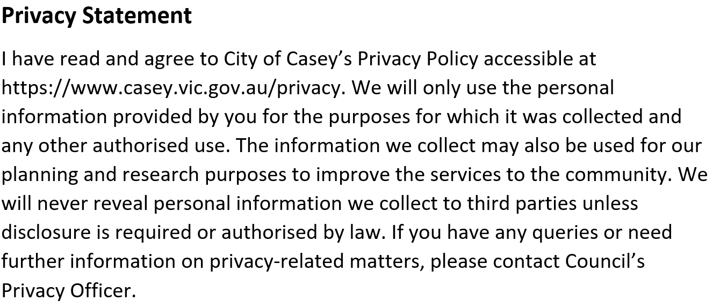

Yes
- Your suburb ^{Required}
Select one answer only

Beaconsfield
Berwick
Blind Bight
Botanic Ridge
Cannons Creek
Clyde
Clyde North
Cranbourne
Cranbourne East
Cranbourne North
Cranbourne South
Cranbourne West
Devon Meadows
Doveton
Endeavour Hills
Eumemmerring
Hallam
Hampton Park
Harkaway
Junction Village
Lynbrook
Lyndhurst
Lysterfield South
Narre Warren
Narre Warren North
Narre Warren South
Pearcedale
Tooradin
Warneet
Outside of Casey
- Your age group
Select one answer only
0 to 9
10 to 14
15 to 19
20 to 24
25 to 29
30 to 39
40 to 54
55 to 69
70+
Prefer not to say
- Your gender
Select one answer only
Woman
Man
Transgender Woman
Transgender Man
Non-binary
Prefer to not say
Self describe option here

- Please tick any of the statement that apply to you. ^{Required}
Select as many as apply
Select all that apply
I am from an Aboriginal and/or Torres Strait Islander background
I speak a language other than English at home
I am a person with a disability
I identify as LGBTIQA+
I'd prefer to not say
None of these apply to me

Tell us about your visits to Wilson Botanic Park

- What is your connection to Wilson Botanic Park? ^{Required}
Select all that apply
I visit the park
I live near the park
I attend events at the park
I work at the park
- When do you typically visit Wilson Botanic Park? ^{Required}
Select all that apply
Weekdays
Weekends
Public holidays
School holidays
Special events
- What time of the day do you typically visit? ^{Required}
Select all that apply
Mornings
Afternoons
Evenings
- When you visit the park, how do you usually get there? ^{Required}
Select all that apply
Walk/run
Bike
Car
All of the above
- Where do you usually park when you visit?
Skip this question if
- your answer to question When you visit the park, how do you usually get there? is not "Car", or "All of the above"

Select all that apply
Wilson Botanic Park car park
Kramer Drive
Bournevale Drive
Conniston Avenue
Grenville Court
William Road
Other (please specify)

- What has your parking experience been when you drive to the park? ^{Required}
Select one answer only
Very difficult to find a park
Difficult to find a park
Neutral
Reasonably easy to find a park
Very easy to find a park
- How does parking availability affect your decision to visit or drive to the park? ^{Required}
Select all that apply
I walk/run/ride
I get dropped off
I park further away and walk the rest
I don't drive there on event days
I avoid park on event days due to lack of parking
It doesn't affect my decision to visit
I don't visit as often as I would like
Other (please specify)

Thinking about the proposed overflow car park on Kramer Drive, Berwick

- Do you support the development of an overflow car park, off Kramer Drive, Berwick? ^{Required}
Select one answer only
Yes
No
Unsure
- If an overflow car park was an option, what would you like Council to consider in the plan?
- On the days the proposed overflow car park would be open, what hours would you prefer it to operate? ^{Required}
Select all that apply
Daylight savings open hours 7am - 9pm
Non-daylight saving hours 7am - 6pm
High car park usage times between 10am - 4pm
I don't support the proposed overflow car park
- Please share any further feedback relating to the proposed overflow car park, off Kramer Drive.
You can upload documents to support your feedback.
- Please upload any documents relating to your feedback.
Maximum 5 documents.
Attach and submit documents with this form - You can provide a maximum of 5 documents
- Would you be interested in participating in a local resident reference group to help shape the plans or mitigate strategies? ^{Required}
Select one answer only
Yes
No
Unsure
- First Name
Skip this question if
- your answer to question Would you be interested in participating in a local resident reference group to help shape the plans or mitigate strategies? is not "Yes" OR
- your answer to question Would you be interested in participating in a local resident reference group to help shape the plans or mitigate strategies? is not "Unsure"

- Surname
Skip this question if
- your answer to question Would you be interested in participating in a local resident reference group to help shape the plans or mitigate strategies? is not "Yes" OR
- your answer to question Would you be interested in participating in a local resident reference group to help shape the plans or mitigate strategies? is not "Yes"

- Your email
Skip this question if
- your answer to question Would you be interested in participating in a local resident reference group to help shape the plans or mitigate strategies? is not "Yes" OR
- your answer to question Would you be interested in participating in a local resident reference group to help shape the plans or mitigate strategies? is not "Yes"

- Best contact number
Skip this question if
- your answer to question Would you be interested in participating in a local resident reference group to help shape the plans or mitigate strategies? is not "Yes" OR
- your answer to question Would you be interested in participating in a local resident reference group to help shape the plans or mitigate strategies? is not "Yes"

- Do you have any further comments you would like to provide?

About your experience in this survey
Only three quick questions.

- How easy or difficult was it to find the information you needed? ^{Required}
Select one answer only
Very easy
Easy
Neutral
Difficult
Very difficult
- How did you hear about the consultation on this project?
Select all that apply
Council e-news (Casey Catch UP)
Council staff member
Council webiste
Direct email
Letter
Signage
Social media
Word of mouth
Other (please specify)

- What was missing?
Skip this question if
- you have not selected either "Neutral", "Difficult", or "Very difficult" in question How easy or difficult was it to find the information you needed?

Return your completed survey to
Vicky Goodwin, Head of Events & Attractions
Post to City of Casey, PO Box 1000 Narre Warren, Victoria 3805
Drop off at one of Customer Service Centres at Bunjil Place or Cranbourne Shopping Centre.

