Subject Line: You’re invited to help shape our City

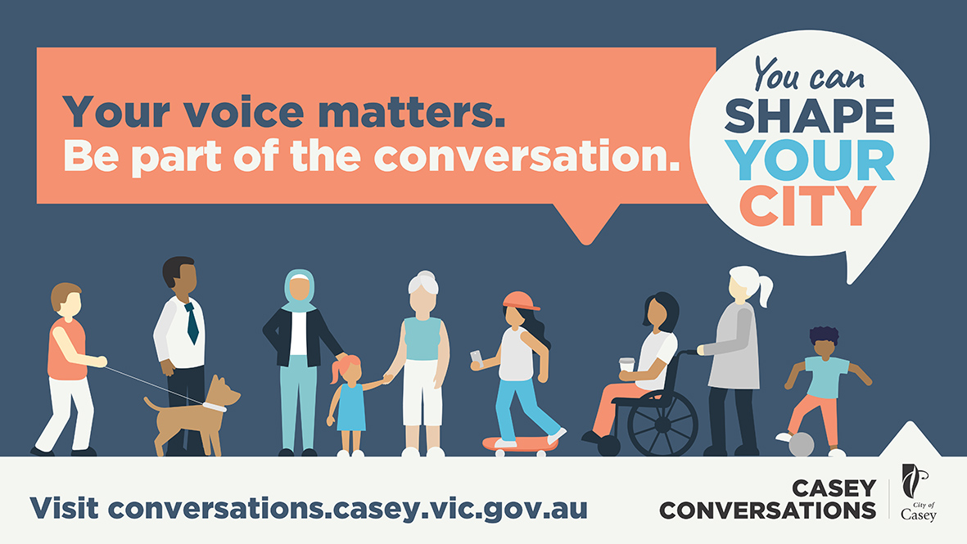

Dear < INSERT NAME>,

The City of Casey is inviting all community members to help develop a 10-year vision for our City and provide a voice and suggestions on the plans that impact future services and infrastructure for where we work, live and play. Whether it’s parks and playgrounds, the arts, community services, local roads or major infrastructure – it's our chance to help shape Casey’s future.

As an ambassador for the Shape your City program I’d like to invite you to join me and other community members for the upcoming How we get around online forum this Saturday 17 October from 3-4pm. This forum was recently rescheduled and we’re hoping to get more members of the community involved.

The one-hour forum will explore the way we move through our streets to get from one place to another by either public transport, private vehicles (including car-pooling), or active modes of transport (such as walking or cycling). This includes travelling to work, education, or local destinations. It’s a really great opportunity for you to get involved in shaping the future for how we get around our City. To join me, please register to attend.

By attending the session you’ll also go into the draw to win 1 of 3, $50 gift vouchers.

If you can’t make it, you can still contribute to the Shape your City program online through Casey Conversations (the City of Casey’s collaboration space).

Your voice matters, so please join me and other community members to help shape the future of our City.

Regards,
<INSERT YOUR NAME>

